cStarting hive and creating a table with the petrol.txt file

Order by query:

Group by:

Sort by:

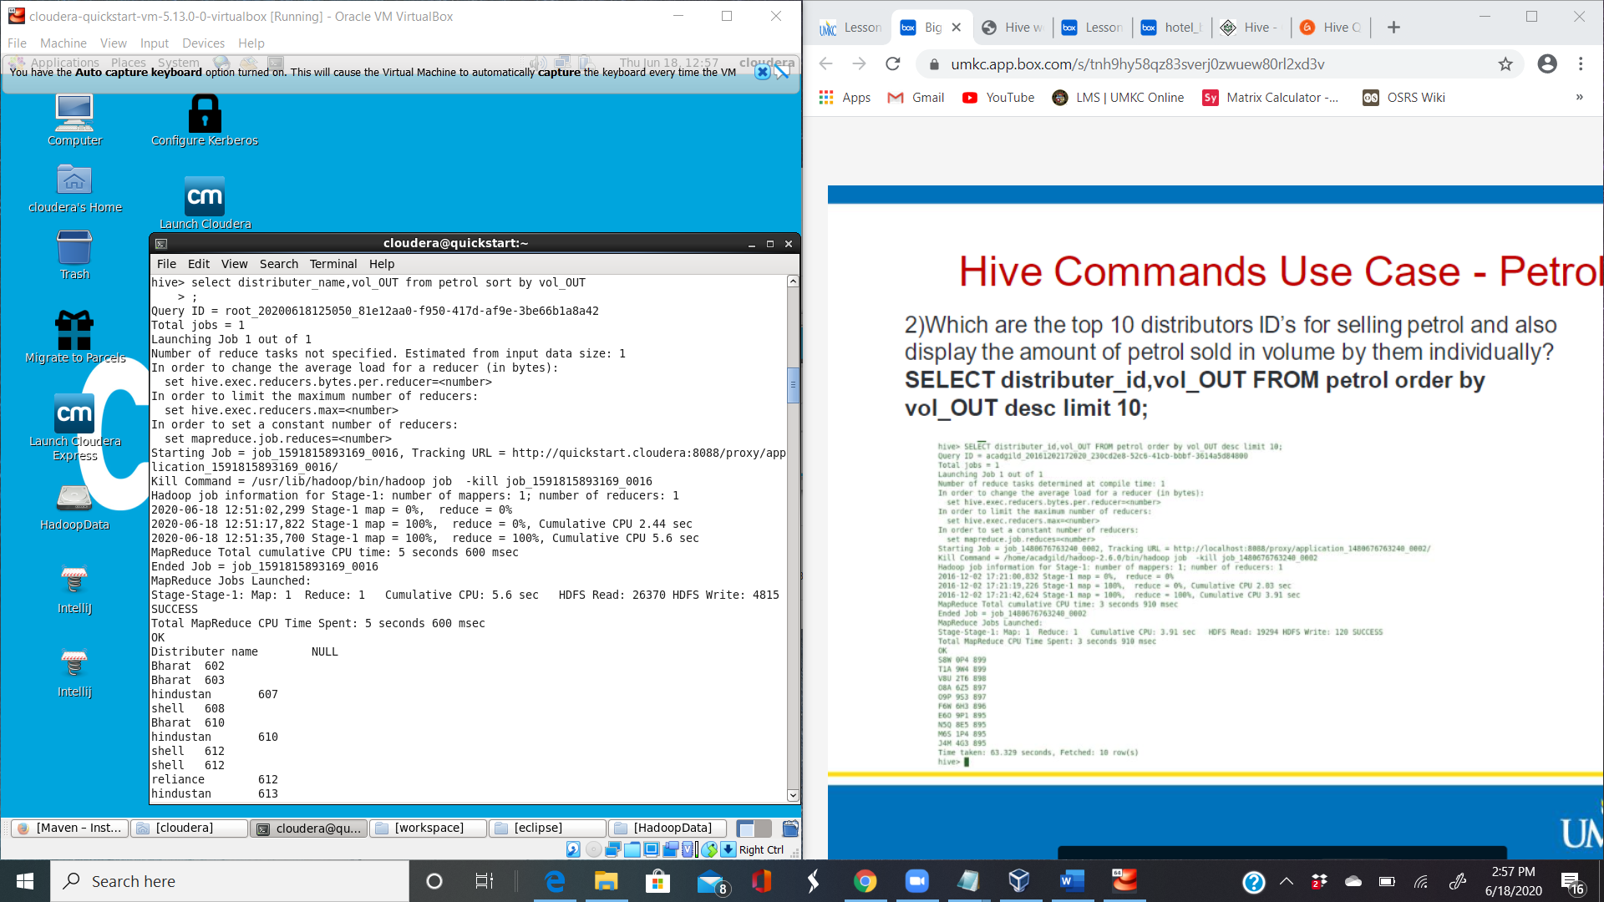

Cluster by:

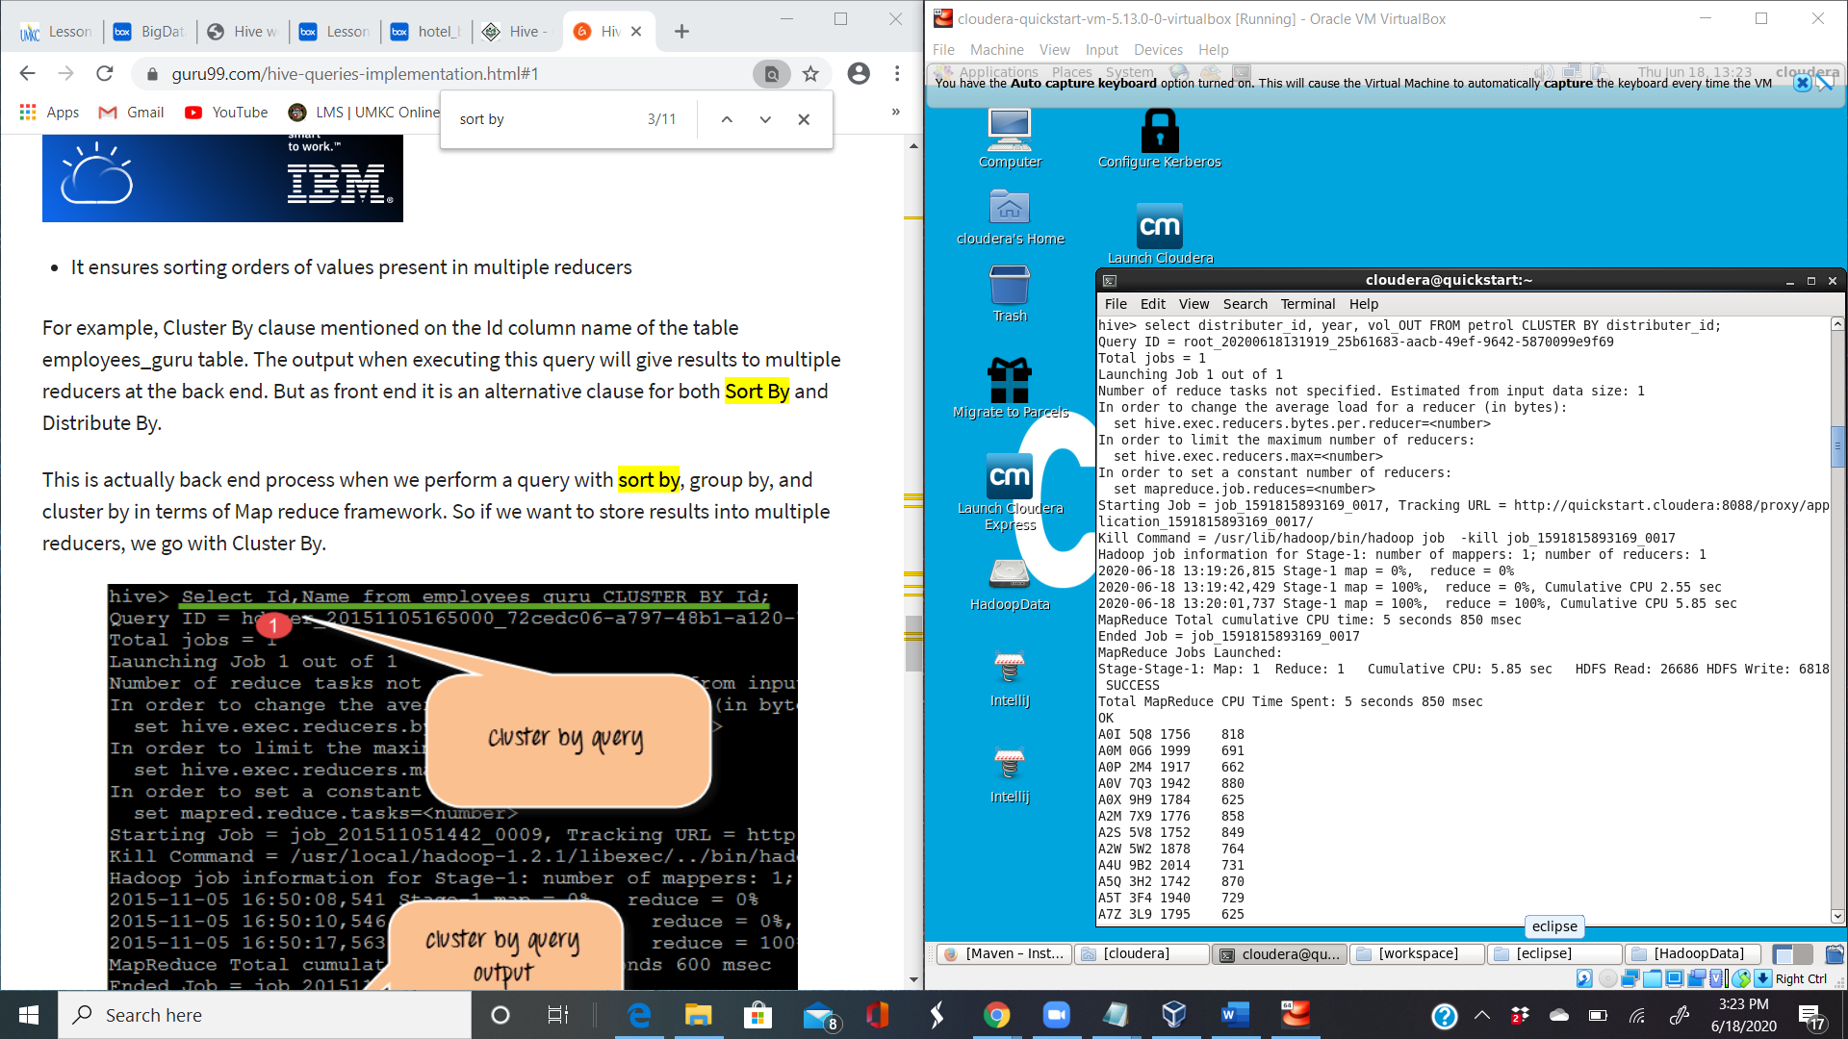

Distribute by

